Master node:

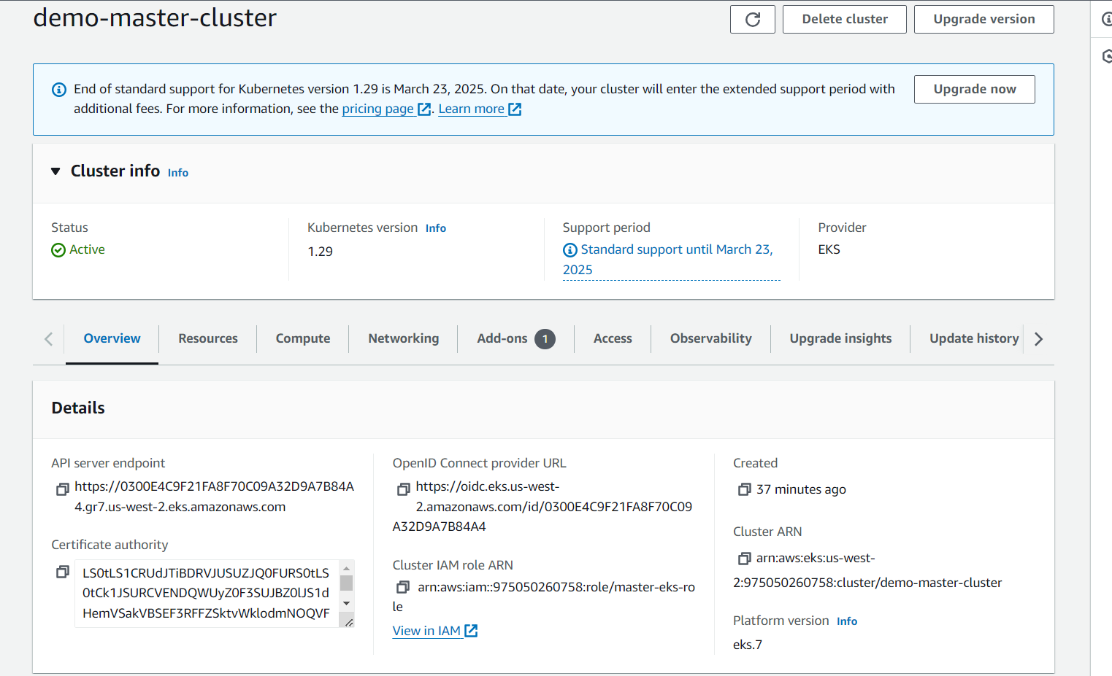

Worker node:

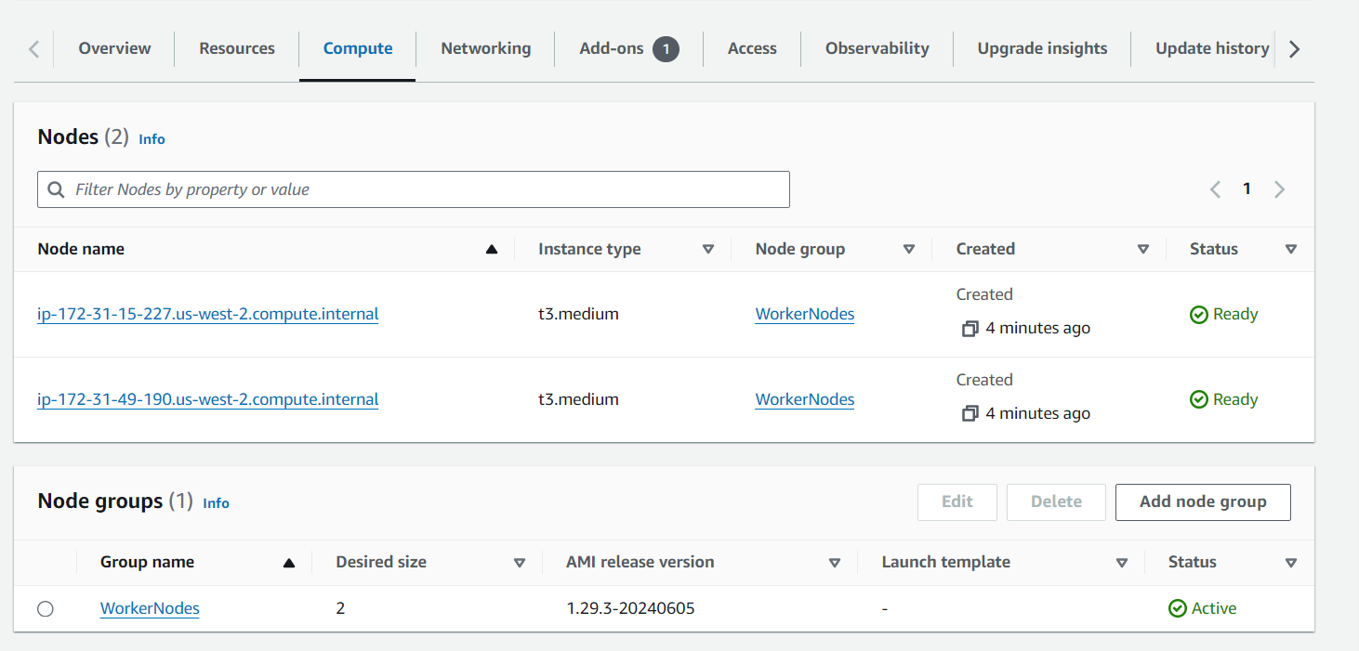

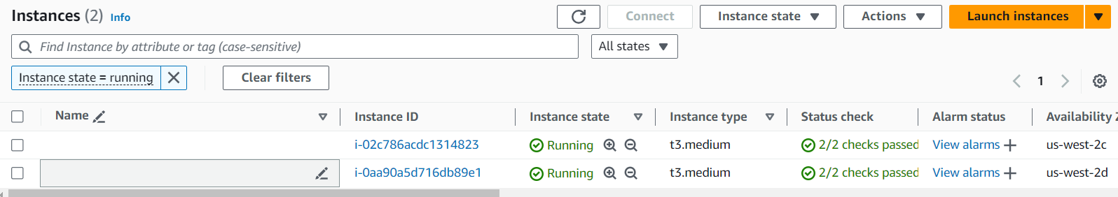

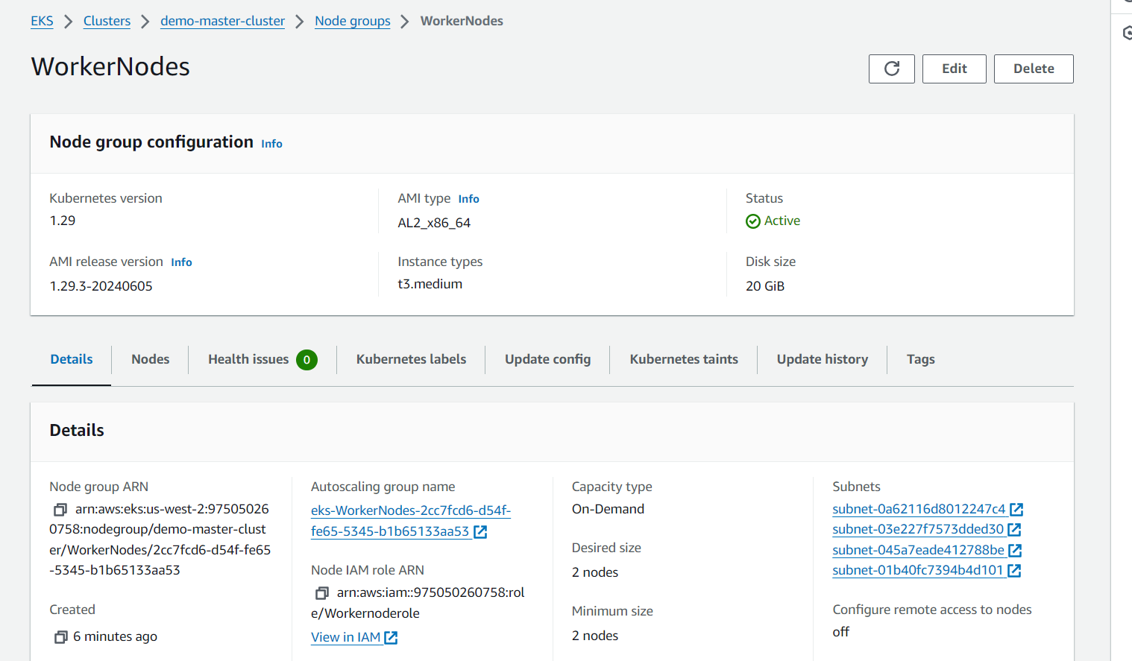

Commands:

Shinav Adhiyan@DESKTOP-5EHG39K MINGW64 /d/Guvi_Sample/k8s

$ kubectl apply -f deploy_nginx.yaml

deployment.apps/nginx-deployment created

Shinav Adhiyan@DESKTOP-5EHG39K MINGW64 /d/Guvi_Sample/k8s

Shinav Adhiyan@DESKTOP-5EHG39K MINGW64 /d/Guvi_Sample/k8s

$ kubectl get pods

NAME READY STATUS RESTARTS AGE

nginx-deployment-77d8468669-jcrf9 1/1 Running 0 52s

nginx-deployment-77d8468669-rjstx 1/1 Running 0 52s

nginx-deployment-77d8468669-t27lr 1/1 Running 0 52s

Shinav Adhiyan@DESKTOP-5EHG39K MINGW64 /d/Guvi_Sample/k8s

$ kubectl get rs

NAME DESIRED CURRENT READY AGE

nginx-deployment-77d8468669 3 3 3 92s

$ kubectl get deploy

NAME READY UP-TO-DATE AVAILABLE AGE

nginx-deployment 3/3 3 3 2m

Code:

apiVersion: apps/v1

kind: Deployment

metadata:

name: nginx-deployment

labels:

app: nginx

spec:

replicas: 3

selector:

matchLabels:

app: nginx

template:

metadata:

labels:

app: nginx

spec:

containers:

- name: nginx

image: nginx:1.14.2

ports:

- containerPort: 80